Security Audit Report

COMMUNE AI-SUBSPACE

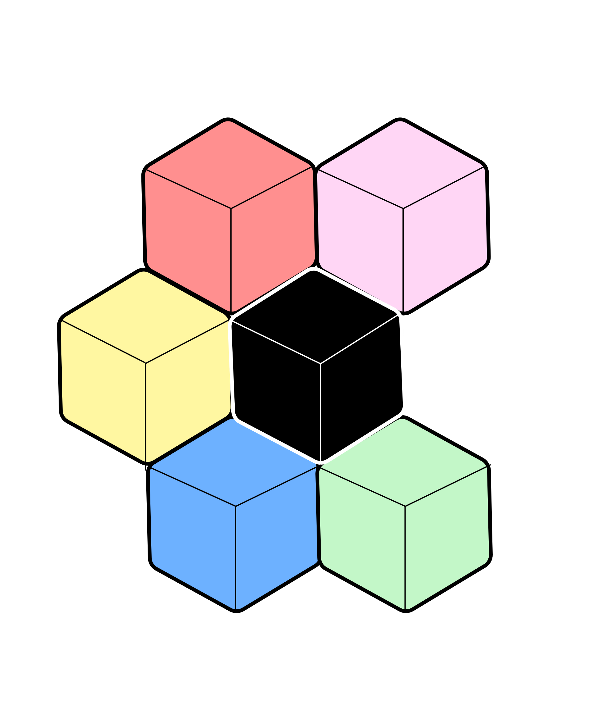Substrate Pallet



by [xfactor.toml@gmail.com](mailto:xfactor.toml@gmail.com)

Jan 17, 2024

**Table of Content**

Disclaimer 4

General Verification 5

Introduction 5

Methodology 5

Findings 6

1. Unresolved Merge Conflict on voting.rs (Major) 6

2. Vulnerable Crate in dependency tree (Medium) 6

3. Rust language server recommended warnings (Minor) 6

Summary 7

Code Verification 8

Introduction 8

Methodology 8

Findings 8

4. Insecure Randomness (Major) 8

5. Bad Extrinsics' Weights (Critical) 9

6. Insufficient Benchmarking (Major) 10

7. Unsafe Arithmetic in balance calculation (Medium) 10

**Audit Summary**

**Scope of initial review**

* Repository: <https://github.com/commune-ai/subspace>
* Commit: cc51b72b33a178af699e0cd37222a374fbf30b2e
* Pallet: ./pallets/subspace
* Node: ./node
* Runtime: ./runtime

**Report objectives**

1. Report all issues in **pallets** alongside recommendations
2. Report all issues in **node** alongside recommendations
3. Report all issues in **runtime** alongside recommendations
4. Report all issues in **test** alongside recommendations
5. Report all **other** issues alongside recommendations

**Audit Methodology**

* Tooling Analysis
* Manual Review

**Issues**

Number of issues reported in the initial review and remaining in the final review:

|  |  |  |  |  |  |  |
| --- | --- | --- | --- | --- | --- | --- |
| Severity | Reported | | | Remaining | | |
| Code | Test | Other | Code | Test | Other |
| Critical | 1 | 0 | 0 | - | - | - |
| Major | 2 | 1 | 0 | - | - | - |
| Medium | 1 | 1 | 0 | - | - | - |
| Minor | 0 | 1 | 0 | - | - | - |

# Disclaimer

The security audit report makes no statements or warranties, either expressed or implied, regarding the security of the code, the information herein or its usage. It also cannot be considered as a sufficient assessment regarding the utility and safety of the code, bug free status or any other statements of the contract.

This report does not constitute legal or investment advice. It is for informational purposes only and is provided on an "as-is" basis. You acknowledge that any use of this report and the information contained herein is at your own risk. The authors of this report shall not be liable to you or any third parties for any acts or omissions undertaken by you or any third parties based on the information contained herein.

# General Verification

## Introduction

Subspace is a Substrate-based chain that were not developed by Parity Technologies. A general verification has been performed, utilizing Tooling Analysis to check if the codebase contains malicious or unverified libraries.

## Methodology

Tooling analysis for General Verification

* cargo-audit (<https://rustsec.org>)

The RustSec Advisory Database is a repository of security advisories filed against Rust crates published via [crates.io](http://crates.io/) maintained by the Rust Secure Code Working Group.

* Static analyzers (<https://github.com/rust-lang/rust-analyzer>)

One of the examples of static analyzers is rust-analyzer. It is a modular compiler frontend for the Rust language. It is a part of a larger rls-2.0 effort to create excellent IDE support for Rust.

* Testing (cargo test)

Writing tests and checking them will help you to be sure that all scripts available for the system will work correctly. Integration tests between pallets are particularly important.

## Findings

### Unresolved Merge Conflict on voting.rs (Major)

Location: pallets/subspace/src/voting.rs:20:1

Approach: cargo build –release

Outcome:

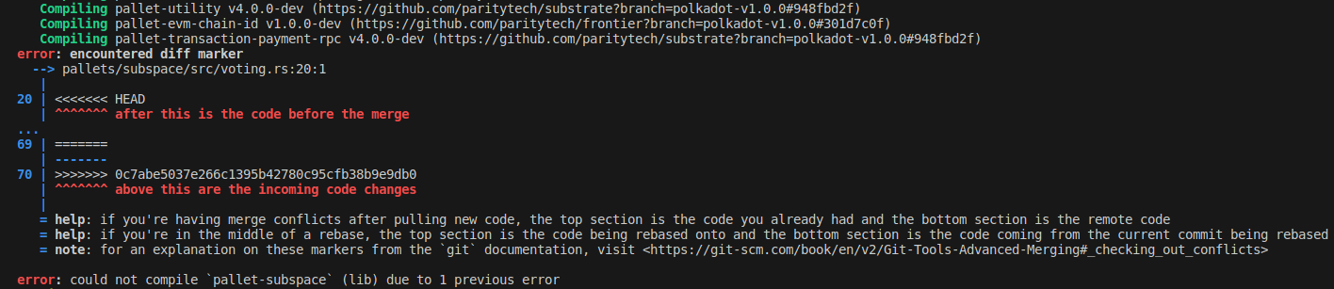

Recommendation: Remove line:20~line:70 to resolve conflict

### Vulnerable Crate in dependency tree (Medium)

Approach:

cargo install cargo-audit

cargo audit

Outcome: <https://rustsec.org/advisories/RUSTSEC-2022-0093>

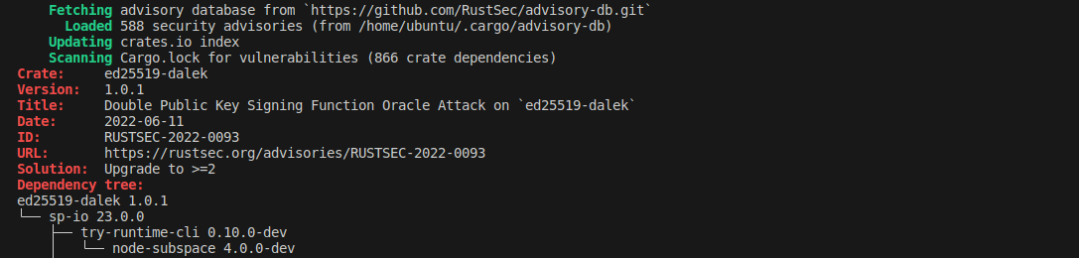

Recommendation: Upgrade to >=2

### Rust language server recommended warnings (Minor)

Approach: Check with Rust-Analyzer

Outcome: 243 warnings

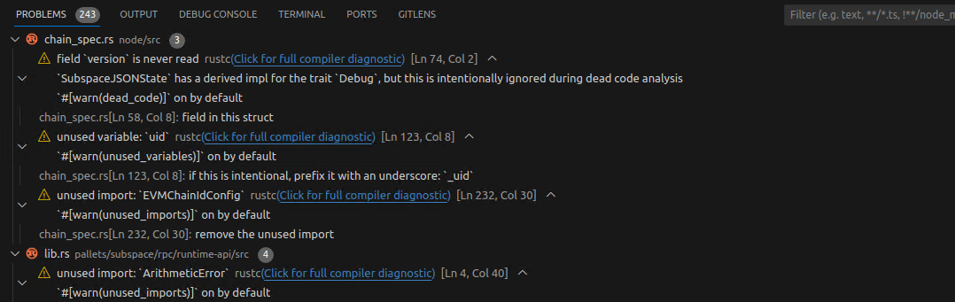

Recommendation:

* Remove unused variables
* Remove unused imports
* Remove unnecessary braces
* Resolve unused `Result` that must be used

## Summary

* Codebase is not following the rust programming convention. It makes the codebase difficult to understand and maintain. It also leads too many warnings and unnecessary memory usage on runtime.
* The dependencies are outdated. The latest polkadot-sdk version is release-polkadot-v1.6.0 but subspace is using release-polkadot-v1.0.0. Parity Technologies is continuously resolve known issues and update polkadot-sdk.

# Code Verification

## Introduction

Code Verification analyzes the logic and algorithms implemented in the codebase. The goal is to ensure that the logic is sound, efficient, and aligned with the desired outcomes. It reviews line-by-line of the code to identify bugs, logic errors, or any unintended behavior.

## Methodology

* Understanding the business logic
* Manual review line by line

## Findings

### Insecure Randomness (Major)

Location:

./pallets/subspace/src/registration.rs:224

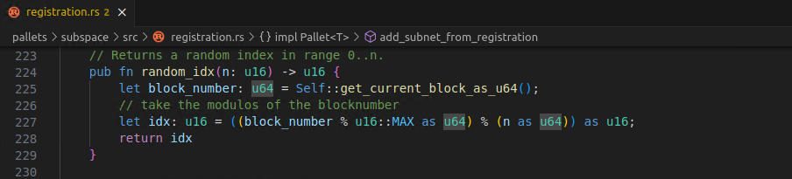

Vulnerability:

Weak random numbers can allow attackers to guess or change the numbers to trick the system.

Recommendation:

Choose a strong method for generating random numbers.

* Find a custom trusted oracle.
* Otherwise, use a method VRF, which Polkadot uses in processes like auctions.

### Bad Extrinsics' Weights (Critical)

Location:

./pallets/subspace/src/lib.rs

Vulnerability: 18 Zero Weights are found.

If the weights are set incorrectly, then spam transactions can cause DoS of a node.

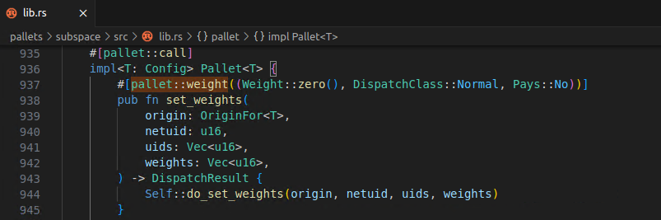

Recommended:

Add missing benchmarking and use autogen_weights.rs

### Insufficient Benchmarking (Major)

Location:

./pallets/subspace/src/benchmarking.rs

Vulnerability:

Insufficient Benchmarking for batch extrinsic calls.

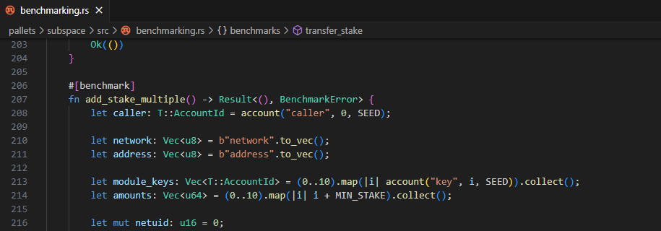

Incorrect or missing benchmarking can slow down the network and it can also let attackers spam the system.

Recommendation:

Run benchmarks using the worst-case scenario conditions. An example is that the benchmark should cover the execution path where more DB reads and writes happen in an extrinsic. The primary goal is to keep the runtime safe, and the secondary goal is to be as accurate as possible to maximize throughput.

### Unsafe Arithmetic in balance calculation (Medium)

Vulnerability:

Unsafe maths operations can lead to wrong calculation results due to overflows/underflows. This might open a door for attackers to trick the system and cause serious inconsistencies.

Recommendation:

Use safe maths functions that check for errors like checked_add or checked_sub, proofread the code for unsafe maths and fix them.